SIMATS ENGINEERING
ASSESSMENT TOOL 1

COURSE NAME: COMPUTER ARCHITECTURE COURSE CODE: CSA1223

COURSE OUTCOME COVERED

CO1: Analyze the functional units of a computer system including CPU, memory, bus structures, and I/O components by examining instruction execution cycles, addressing modes, and performance metrics such as CPI, clock cycles, and benchmarking (BL4)
Assessment Tool Weightage: 40%

QUESTIONS:5 Total Marks:25

ANNEXURE A
APPLICATION BASED QUESTIONS

Code of Conduct:

I __________VARSHA VARDHINI S (192511488)__________ (Name / Reg No) certify that this submission is my original work and that I have adhered to the guidelines specified for this assessment. I understand that any violation of academic integrity rules will result in disciplinary action.

Signature of the student:

ANNEXURE A
- A smart city surveillance system processes continuous video feeds from multiple cameras, where large volumes of data are transferred between I/O devices, memory, and CPU. During peak hours, the system experiences lag and delayed response in threat detection. Analyze how the interaction between CPU, memory, and I/O contributes to this issue, and explain how different bus structures (single-bus vs multi-bus) and improvements in instruction execution cycle can enhance system performance.
- A real-time stock trading application running on a processor executes millions of instructions per second, but users report delays in transaction processing during high load. The system has a high CPI due to frequent memory access and branch instructions. Examine how the fetch–decode–execute cycle impacts execution time in this scenario, and propose methods to reduce CPI and improve overall CPU performance using suitable architectural enhancements.
- An embedded system based on an 8085 microprocessor is used in an industrial temperature control unit, where sensors provide input and actuators respond accordingly. However, incorrect temperature readings are occasionally processed due to improper use of addressing modes in the program. Discuss how different addressing modes influence data access, identify possible causes
of such errors, and suggest how the instruction set of 8085 can be effectively used to ensure accurate and reliable operation.
- A computing system uses an 8086 microprocessor with segmented memory for executing multiple programs simultaneously, but it encounters issues like incorrect data access and stack overflow errors. Evaluate how segmentation (code, data, and stack segments) works in 8086, analyze how improper segment handling can lead to such problems, and explain how instruction execution and addressing modes must be managed to ensure correct program execution.
- A data communication system represents packet information in hexadecimal format for ease of debugging and transmission, but a software engineer mistakenly interprets values, leading to incorrect data processing. Analyze the importance of number system conversions between hexadecimal and binary in such systems, explain how errors in conversion can affect instruction execution, and discuss how efficient CPU design and benchmarking can help detect and minimize such issues in real-time systems.
ANSWERS
- Smart City Surveillance System
Analysis of the Problem
In the given smart city surveillance system, multiple surveillance cameras continuously generate high-resolution video streams. These cameras act as I/O devices and continuously transfer data to the main memory (RAM). The CPU fetches the video frames from memory, decodes the instructions, executes image-processing algorithms, and identifies suspicious activities. During peak hours, the number of incoming video streams increases significantly. As a result, the CPU, memory, and I/O devices simultaneously request access to the system bus, leading to congestion, increased memory access time, CPU waiting time, and delayed threat detection.
Interaction between CPU, Memory and I/O
I/O devices (Cameras): Capture continuous video frames and send them to the system.
Memory (RAM): Temporarily stores the incoming video frames and program instructions.
CPU: Fetches instructions and video data from memory, processes the frames, and generates the final threat detection output.
When video traffic increases, the CPU cannot process all the data immediately because it spends additional clock cycles waiting for memory access. This reduces overall system performance and increases response time.
Impact of Bus Structure
In a single-bus architecture, the CPU, memory, and I/O devices share one common communication bus. Since only one transfer can occur at a time, simultaneous requests from multiple cameras create bus contention, resulting in delays and lower throughput.
In contrast, a multi-bus architecture provides separate buses for CPU-memory communication and I/O communication. While one bus transfers video frames from cameras to memory, another bus allows the CPU to fetch instructions and process data simultaneously. This parallel communication minimizes waiting time, increases bandwidth, and significantly improves the efficiency of the surveillance system.
Improving the Instruction Execution Cycle
The CPU follows the instruction execution cycle:
Fetch → Decode → Execute → Store
Performance can be enhanced by:
Instruction Pipelining: Executes multiple instructions simultaneously, reducing execution time.
Cache Memory: Stores frequently accessed instructions and video data, reducing RAM access delays.
Direct Memory Access (DMA): Enables video data to be transferred directly from I/O devices to memory without continuous CPU involvement.
Branch Prediction: Reduces delays caused by conditional instructions.
Parallel Processing: Allows simultaneous processing of multiple video streams.
These improvements reduce CPU idle time, improve throughput, and ensure faster threat detection even during peak traffic.
Conclusion
Therefore, the surveillance system can achieve faster and more reliable real-time threat detection by adopting a multi-bus architecture, optimizing the instruction execution cycle, implementing cache memory, DMA, and instruction pipelining. These architectural improvements minimize bus contention, reduce CPU waiting time, and significantly enhance overall system performance.

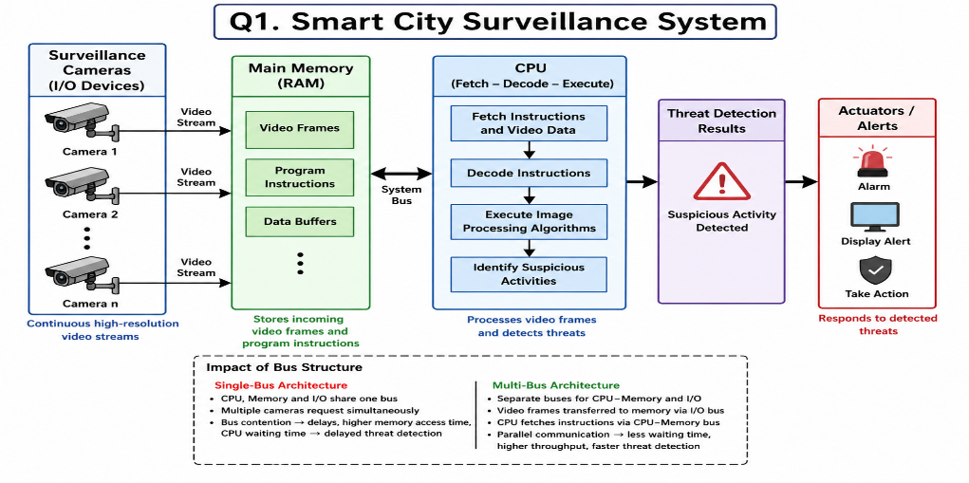

- Real-Time Stock Trading Application

Analysis
A real-time stock trading system executes millions of instructions every second. During high load, frequent memory access and branch instructions increase the Cycles Per Instruction (CPI), causing delays in transaction processing.

Impact of Fetch–Decode–Execute Cycle
- Fetch: CPU fetches instructions from memory. Frequent memory access increases fetch time.
- Decode: Branch instructions require additional decoding and may cause pipeline stalls.
- Execute: The CPU waits if required data is unavailable, increasing execution time.
- Write Back: Results are stored in registers/memory, and heavy memory traffic causes additional delay.

High CPI → More Clock Cycles → Increased Execution Time → Delayed Transactions

Methods to Reduce CPI
- Cache Memory: Reduces memory access time.
- Instruction Pipelining: Executes multiple instructions simultaneously.
- Branch Prediction: Reduces delays caused by branch instructions.
- Out-of-Order Execution: Executes independent instructions while waiting for memory.
- Superscalar Architecture: Executes multiple instructions in one clock cycle.
- High-Speed Memory: Improves data access speed.

Architectural Enhancements
- Multi-core processors
- L1/L2/L3 Cache
- Pipeline optimization
- Branch prediction
- Faster memory hierarchy

Conclusion
Using cache memory, pipelining, branch prediction, superscalar execution, and faster memory systems reduces CPI, improves CPU performance, decreases execution time, and enables faster real-time transaction processing.
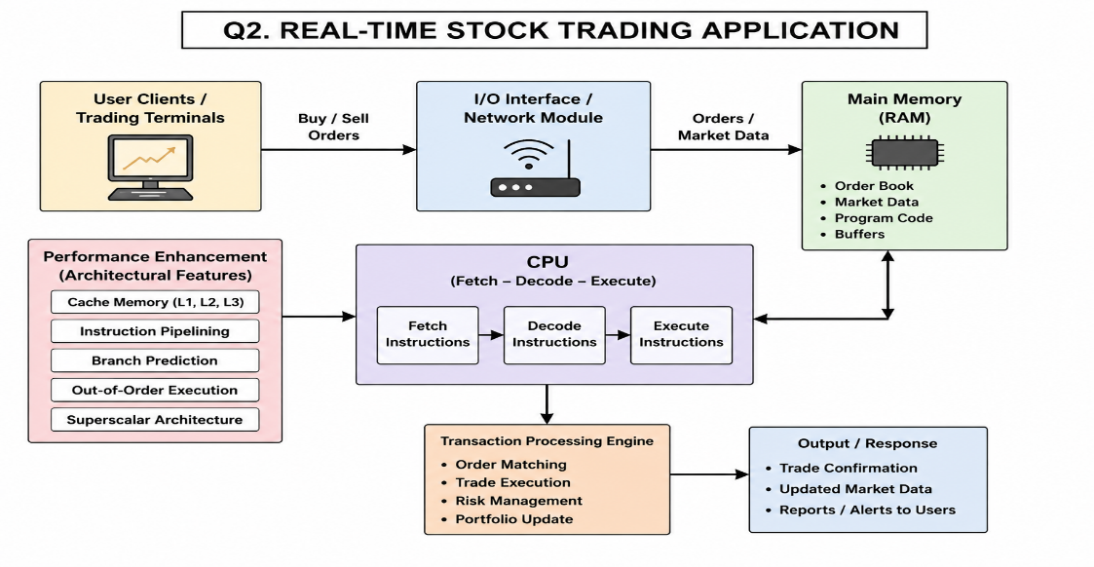

- 8085 Temperature Control System
Analysis
In an industrial temperature control system, sensors continuously send temperature data to the 8085 microprocessor, which processes the data and controls actuators such as cooling fans or heaters. If the program uses an incorrect addressing mode, the CPU may read data from the wrong register or memory location, resulting in incorrect temperature readings and improper control actions.

Influence of Addressing Modes on Data Access
- Immediate Addressing: Data is provided directly in the instruction (e.g., MVI A,25H). Suitable for fixed values.
- Register Addressing: Data is transferred between registers (e.g., MOV A,B). Faster because data is inside the CPU.
- Direct Addressing: Data is accessed from a specified memory location (e.g., LDA 2050H). Used for stored sensor values.
- Register Indirect Addressing: The memory address is stored in the HL register pair (e.g., MOV A,M). Useful for sequential sensor data.

Possible Causes of Errors
- Incorrect memory address used.
- Wrong addressing mode selected.
- Sensor data overwritten in memory.
- Improper register initialization.
- Invalid instruction sequence leading to incorrect data access.

Effective Use of 8085 Instruction Set
- LDA / STA – Read and store sensor values correctly.
- MOV / MVI – Transfer data between registers.
- LXI – Load correct memory addresses.
- CMP – Compare temperature with the reference value.
- JZ / JC / JNC – Make correct control decisions.
- HLT – Stop execution after successful operation.

Conclusion
Selecting the correct addressing mode and using appropriate 8085 instructions ensures accurate sensor data access, reliable temperature processing, correct actuator response, and stable operation of the industrial temperature control system.

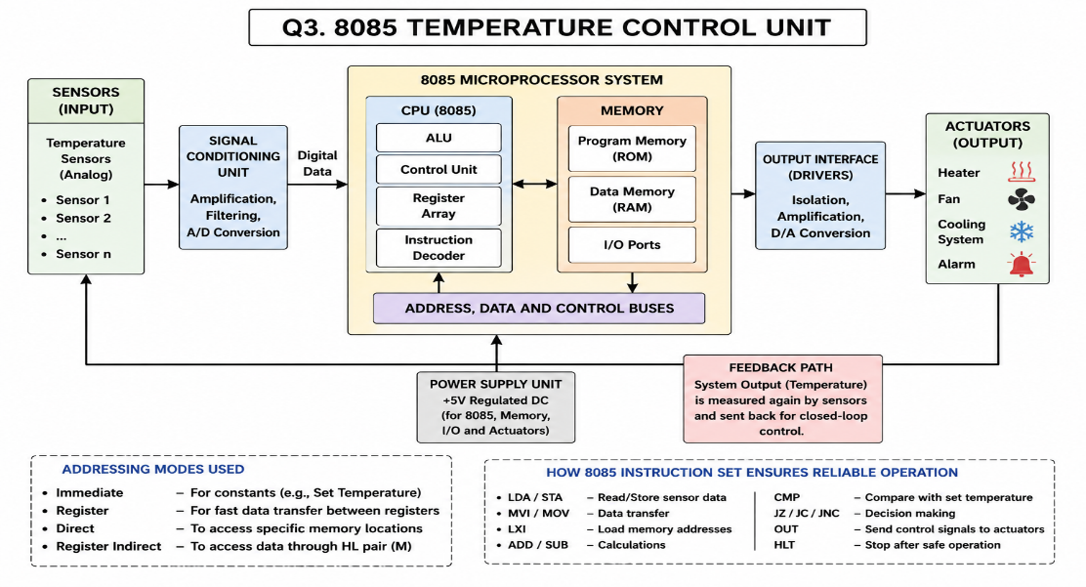

- 8086 Segmented Memory

Analysis
The 8086 microprocessor uses segmented memory to organize memory efficiently and support the execution of multiple programs. Memory is divided into Code Segment (CS), Data Segment (DS), and Stack Segment (SS). If these segments are not managed properly, the processor may access incorrect memory locations, resulting in data errors and stack overflow.

Working of Segmentation
- Code Segment (CS): Stores program instructions and works with the Instruction Pointer (IP).
- Data Segment (DS): Stores variables and input/output data.
- Stack Segment (SS): Stores return addresses, local variables, and temporary data using the Stack Pointer (SP)
.
Causes of Incorrect Data Access
- Incorrect initialization of segment registers (CS, DS, SS).
- Wrong offset address.
- Accessing data from the wrong segment.
- Incorrect addressing mode selection.

Causes of Stack Overflow
- Excessive PUSH operations without corresponding POP operations.
- Deep function calls or recursion.
- Improper Stack Pointer (SP) management.

Managing Instruction Execution
- Execute instructions using the correct CS:IP combination.
- Access variables through the correct DS.
- Use SS:SP properly for stack operations.
- Maintain the sequence Fetch → Decode → Execute → Write Back to ensure correct execution.

Managing Addressing Modes
- Use Immediate Addressing for constants.
- Use Register Addressing for faster operations.
- Use Direct Addressing for fixed memory locations.
- Use Based/Indexed Addressing for arrays and multiple program data.

Conclusion

Proper segment initialization, correct addressing modes, and efficient stack management prevent incorrect data access and stack overflow, ensuring reliable execution of multiple programs in the 8086 microprocessor.

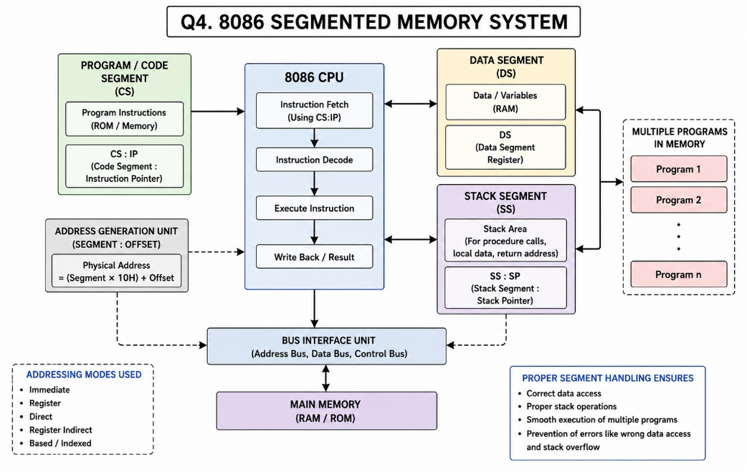

- Analysis
In a data communication system, packet information is represented in hexadecimal because it is compact and easy to read. However, the CPU processes all instructions in binary. If a software engineer incorrectly converts hexadecimal values to binary, the processor may interpret the wrong instruction or data, leading to incorrect packet processing and communication errors.

Importance of Hexadecimal–Binary Conversion
- Hexadecimal provides a compact representation of binary data.
- Each hexadecimal digit represents 4 binary bits.
- Accurate conversion ensures correct instruction decoding.
- Simplifies debugging and memory address representation.

Effects of Incorrect Conversion
- Wrong instruction execution.
- Incorrect memory address access.
- Data corruption during packet processing.
- Communication failures and system errors.

Role of Efficient CPU Design
- Cache memory reduces data access time.
- Error detection mechanisms identify invalid data.
- Efficient instruction decoding minimizes execution errors.
- Pipeline optimization improves processing speed.

Role of Benchmarking
- Measures CPU execution time and CPI.
- Detects performance bottlenecks.
- Evaluates instruction execution efficiency.
- Helps optimize real-time system performance.

Conclusion
Accurate hexadecimal-to-binary conversion, combined with efficient CPU architecture and benchmarking, ensures correct instruction execution, reliable packet processing, and improved performance in real-time data communication systems

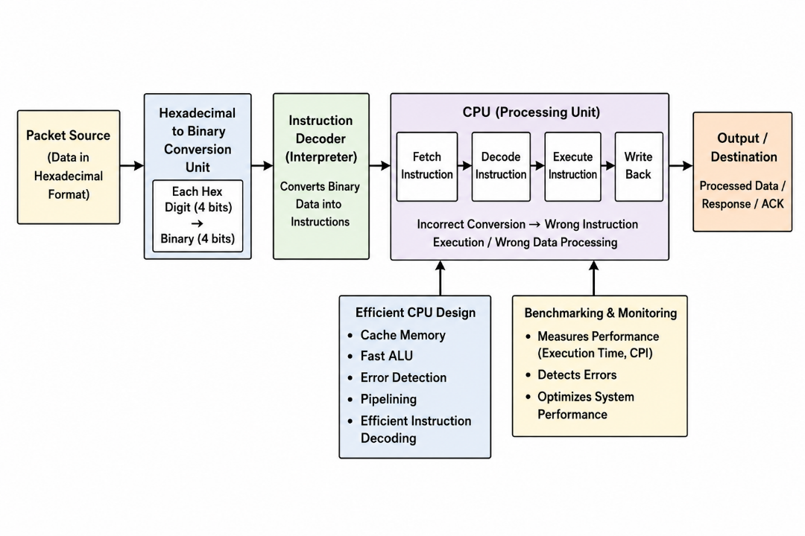
MARKS ALLOCATION
Criteria | Understanding of Problem  Context (20%) | Application of  Concepts  (20%) | Problem-Solving Approach (20%) | Accuracy of  Solution  (20%) | Clarity (20%)
Q1
Q2
Q3
Q4
Q5

RUBRICS FOR CALCULATION:
Criteria | Weightage | Level 4 –  Exemplary | Level 3 –  Proficient | Level 2 –  Developing | Level 1 –  Beginning
Understan ding of  Problem  Context | 20 | Clearly understands the problem and  accurately identifies all requirements | Good understanding with minor gaps | Basic understanding; some  requirements unclear | Poor understanding or  misinterpretation of the problem
Application  of  Concepts | 30 | Accurately applies appropriate  concepts to solve complex problems | Applies relevant concepts correctly with minor errors | Applies basic concepts with limited accuracy | Fails to apply appropriate concepts
Problem-S olving  Approach | 20 | Logical, well-structured, and efficient approach | Mostly logical approach with minor gaps | Basic approach with some inconsistencies | Illogical or unclear approach
Accuracy of Solution | 20 | Completely correct solution with proper justification | Mostly correct with minor errors | Partially correct solution | Incorrect or incomplete solution
Clarity | 10 | Clear, well-organized, and  properly explained solution | Understandable with minor clarity issues | Limited clarity and  explanation | Poorly presented and difficult to understand

